Ref - Mittal P, Panchal K, Chikara P, Paliwal PK. Sternum: The Tell Tale of Foetal age. Anil Aggrawal's Internet Journal of Forensic Medicine and Toxicology [serial online], 2013; Vol. 14, No. 1 (Jan - June 2013): [about 6 p]. Available from: https://anilaggrawal.com/ij/vol_014_no_001/papers/paper003.html. Published : Jan 1, 2013.
Access the journal at - http://anilaggrawal.com
******************************
Sternum: The Tell Tale of Foetal age
Pawan Mittal*, Kuldeep Panchal*, Pankaj Chikara**, P.K Paliwal****
Resident*, Demonstrator**, Sr. Prof. & Head****
Department of Forensic Medicine
Pt. B.D. Sharma PGIMS, Rohtak (Haryana)
Correspondence: drmittalpawan@gmail.com, 09996031331
Abstract:
Determination of age of foetus has a lot of medico-legal importance. Its importance lies in ascertaining the age of viability and foeticide. But it becomes practically difficult to determine the age when foetus is decomposed or mutilated. Under these circumstances opinion regarding the age of foetus is framed on the basis of available bones and for that we have to depend on the appearance of different centres of ossification. Such a case was referred to the department of Forensic Medicine PGIMS, Rohtak. The same is described here.
Keywords: Foetal age, Sternum, Tarsals, Ossification.
Introduction:
Estimating the foetal age is an important work of forensic medicine and in the forensic context there are cases involving fetal and neonatal skeletal remains. The determination of foetal age from ossification centres located at the ends of the long bones like lower end of femur & upper end of tibia, & from the tarsals like calcaneum, talus and cuboid is a common practice during foetal autopsy. But at time of autopsy each bone may or may not be present for autopsy, and even if so, may be brought in severe fragmentary condition. Compared to adult individual analysis, when the foetal remains are complete, aging is relatively easy. The problem arises when only a few bones are present.¹ In such circumstances, the Rule of Hasse, as commonly employed in estimating the age of foetus, turns out to be insignificant. Performing the foetal autopsy when only foetal remains are available is mainly aimed at calculating the age of the foetus.
Age estimation is usually the primary characteristic for identification and is often the only means of identification for foetuses and neonates since they do not usually have any other type of identification with them.²⁻⁴Accurate age estimation of these remains can be very important to medico-legal authorities, particularly as it is sometimes necessary to determine if these skeletal remains are those of a full-term neonate or a pre-term foetus and to check the viability of the foetus. But the soft tissues of foetal remains from the forensic context are often so deteriorated that accurate estimations of size and age can only be made after the remains are processed into clean, dry bones.⁵
Many times all routinely examined bones, especially long bones & tarsals, may be absent or present in very fragmentary conditions not suitable for examination in the foetal remains brought for autopsy. In such cases, a careful autopsy along with the broad and accurate knowledge of foetal skeleton pertaining to the time of appearance of ossification centres of other bones, as explained for sternum below, proves the chief helpful element and solves the problem.
The age of appearance of different centres of ossification in all the six segments of sternum is depicted in Figure 1.⁶ The first center makes its appearance in the manubrium and thereafter the centres appear and proceed gradually downward.
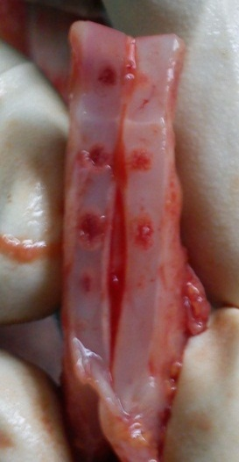
Xiphisternum (3rd-18th years), not appeared
Manubrium (5th month)
S₄ Sternebrae (10thmonth), not appeared
S₃Sternebrae (7thmonth)
S₂Sternebrae (7thmonth)
S₁ Sternebrae (6th month)
1. Appearance of centres of ossification of sternum (40 weeks>Viable foetus≥28weeks).
Case history:
A case was referred to the Department of Forensic Medicine, Pt. B.D. Sharma PGIMS, Rohtak by the board of Medical officers. The death of the foetus had occurred 2 months back and at that time it was referred to the department of pathology for autopsy by the board of doctors for ascertaining the age as they were not knowing whether age determination is done by the department of Pathology or Forensic Medicine and was referred subsequently to the department of Forensic Medicine. But by that time the body of the foetus was converted into only the fragmentary skeletal remains and some masses of decomposed tissues and placenta. The main motive of the autopsy was to find out the age of the foetus in context to its viability. The cause of death and sex could not be ascertained as body of foetus was converted into skeletal remains and clumps of decomposed tissues. All the clumps of decomposed tissue, placenta and the skeletal remains were segregated, cleaned and dried and kept on a white paper as depicted in Figure 2 and 3.
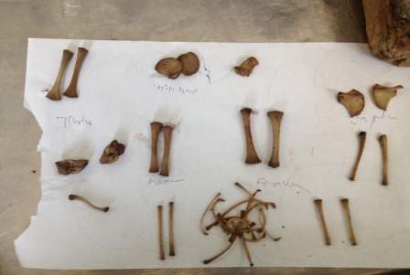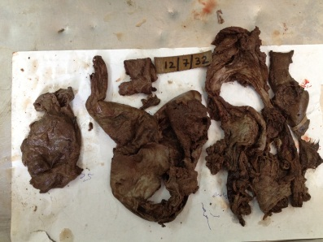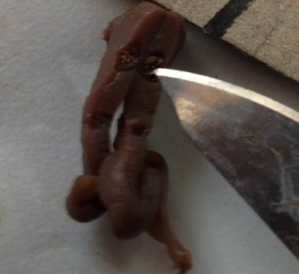
2. Skeletal Remains 3. Decomposed tissues 4. Manubrium Ossification Centre
The ends of long bones and all the tarsals were missing so it seemed to be a tough task to ascertain the age of this foetus. But when the sternum was dissected in its middle to look for the ossification centres of its segments, the whole picture became clear as apparent from the figure 4.
The ossification centre was appeared in the manubrium while it was absent for rest of the segments below. The opinion was framed as that the skeletal remains brought for the autopsy are of a nonviable foetus aged between 20 to 24 weeks (i.e. between 5 to 6 months).
Discussion:
In the Forensic medicine cases of estimation of foetal age are frequently seen. In cases of infanticide, the age of the foetus is integral to the prosecution.⁷ The study of foetal skeletal development has been of interest for centuries. The first known studies were conducted by Galen (ca. 130-200 A.D.) who recorded seven ossification centers in the sternum and two in the mandible.⁷Since that time, the process of ossification of fetal bones has been well documented and is relatively well understood. Ossification occurs at specific points called ossification centres. Since the prenatal environment protects the foetus from nutritional deficiencies, the appearance of ossification centres does not show much variability.⁸ In particular, the ossification centers in the long bones appear around the same time.⁹ The ossification of long bones begins in the center of the diaphysis and progresses towards the ends of the bones.¹⁰
The process of ossification is well understood and provides a way for forensic osteologists to estimate the age of foetal remains and discern if they are those of a foetus or neonate. The same becomes easy when the remains consist of ends of the intact long bones or the tarsal bones, which could be searched for their ossification centres. But the problem arises when all these are in a compromised situation in the remains. In these situations, the thorough search and careful autopsy of foetal remains becomes part and parcel as the bones like sternum are often not searched and thought of, which prove to be the sole determinant sometimes.
Conclusion:
Generally an opinion about age is given by combining multiple bone findings but in foetus a little change in opinion is there. As the ossification occurs at specific points called ossification centres and at specific period of time in foetus, a single bone may sometimes do the job of determining the age of foetus in certain circumstances.
References:
- Fazekas I GY, and Kosa F. 1978. Forensic Fetal Osteology. Budapest: Akademiai Kaido.
- Hoffman JM. 1979. Age estimations from diaphyseal lengths: two months to twelveyears. J For Sci; 24:461-9.
- Scheuer JL, Musgrave JH, and Evans SP. 1980. The estimation of late fetal andperinatal age from limb bone length by linear and logarithmic regression. Ann Hum Biol; 7:257-65.
- Weaver DS. 1998. Forensic Aspects of Fetal and Neonatal Skeletons. In: Reichs KJ editor. Forensic Osteology: Advances in the Identification of Human Remains, 2ndEdition. Springfield: Charles C. Thomas:187-203.
- Stewart T. 1979. Essentials of Forensic Anthropology. Springfield: Charles C. Thomas.
- Umadethan B. Forensic Medicine. 1st ed. New Delhi: CBS Publishers & Distributers; 2011: p.56.
- Noback CR. 1944. The developmental anatomy of the human osseous skeleton during the embryonic, fetal and circumnatal periods. Anat Rec 88(1):91-117.
- Hill AH. 1939. Fetal age assessment by centers of ossification. Am J Phys Anthropol 24(3):251-72.
- NobackCR, and Robertson GG. 1951. Sequences of appearance of ossification centers in the human skeleton during the first five prenatal months. Am J Anat 89(1):1-28.
- Deter RL, Rossavik IK, Hill RM, Cortissoz C, and Hadlock FP. 1987. Longitudinal studies of femur growth in normal fetuses. J Clin Ultrasound 15:299-305.

